Unit 12 Assignment 3

# Problem Solving Scenario:

Client calls with problem starting Word

Which version of Word? 2007

Are there any errors displayed? Some message about Normal.dot

Use search engine to research the problem about Normal.dot. There are numerous hits in search engines for this problem. Some are from third-party support companies and some are from support forums.

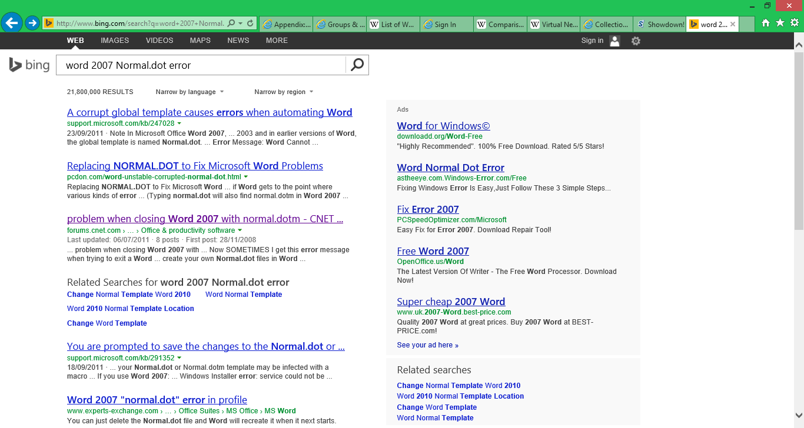

Research the problem on the Microsoft KnowledgeBase turns up a solution. I selected the Microsoft one as being most authoritative and reliable.

**How to troubleshoot problems that occur when you start or use Word**<http://support.microsoft.com/kb/921541>   
“This article describes how to troubleshoot problems that may occur when you start or use Microsoft Word 2013, Microsoft Word 2010, Microsoft Office Word 2007, or Microsoft Office Word 2003.”

This article has a section entitled “Rename the Normal.dot or Normal.dotm global template file”. This will allow Word to recreate a default global template, bypassing one which may be corrupt. Renaming the file allows it to be replaced if this is not the problem. Also the article advises that “options that are reset include custom styles, custom toolbars, macros, and AutoText entries”, so the client needs to be aware of this.

The following steps are described to help resolve the problem.

1. Exit all Office programs.
2. In Windows 8 or Windows 8.1, swipe in from the right edge of the screen, and then tap **Search**. (If you're using a mouse, point to the upper-right corner of the screen, move the mouse pointer down, and then click Search.) Type **Command Prompt** in the search box, tap or click Apps, and then tap or click **Run**.   
   Or, in Windows 7, Windows Vista or Windows XP, click **Start**, click **Run**, type **cmd**, and then click **OK**.
3. Type the following command, as appropriate for the version of Word that you are running, and then press Enter:
   * **Word 2013, Word 2010 and Word 2007**

Windows 8 or Windows 8.1, Windows 7 or Windows Vista:  
**ren %userprofile%\AppData\Roaming\Microsoft\Templates\Normal.dotm OldNormal.dotm**  
Type **exit**, and then press Enter.

1. Start Word.

The problem has been resolved! The client was not aware of any modifications which had been made to the normal.dot, so no further action is required.

Questionnaire:

|  |  |  |
| --- | --- | --- |
| No. | Question | Poor Great |
|  | Were you happy with the response time for this problem? | 1 2 3 4 5 6 7 8 9 10 |
|  | Was the IT Support technician helpful and friendly? | 1 2 3 4 5 6 7 8 9 10 |
|  | Did the IT Support technician explain things in a way which you understood? | 1 2 3 4 5 6 7 8 9 10 |
|  | Were you happy with the apparent knowledge of the technician? | 1 2 3 4 5 6 7 8 9 10 |
|  | Were you happy with the length of time taken to resolve the problem? | 1 2 3 4 5 6 7 8 9 10 |
|  | Were you happy with the problem resolution which was delivered? | 1 2 3 4 5 6 7 8 9 10 |